Result 1

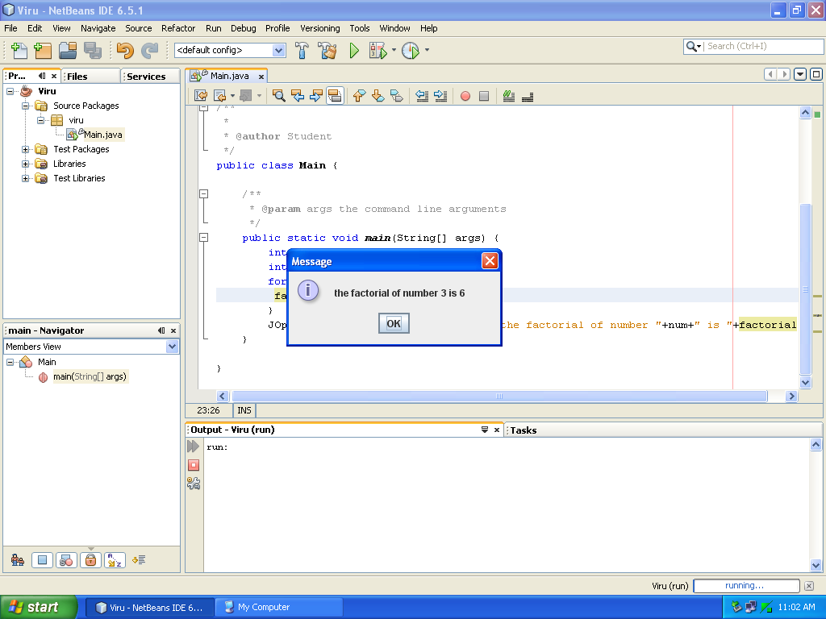

Result 2

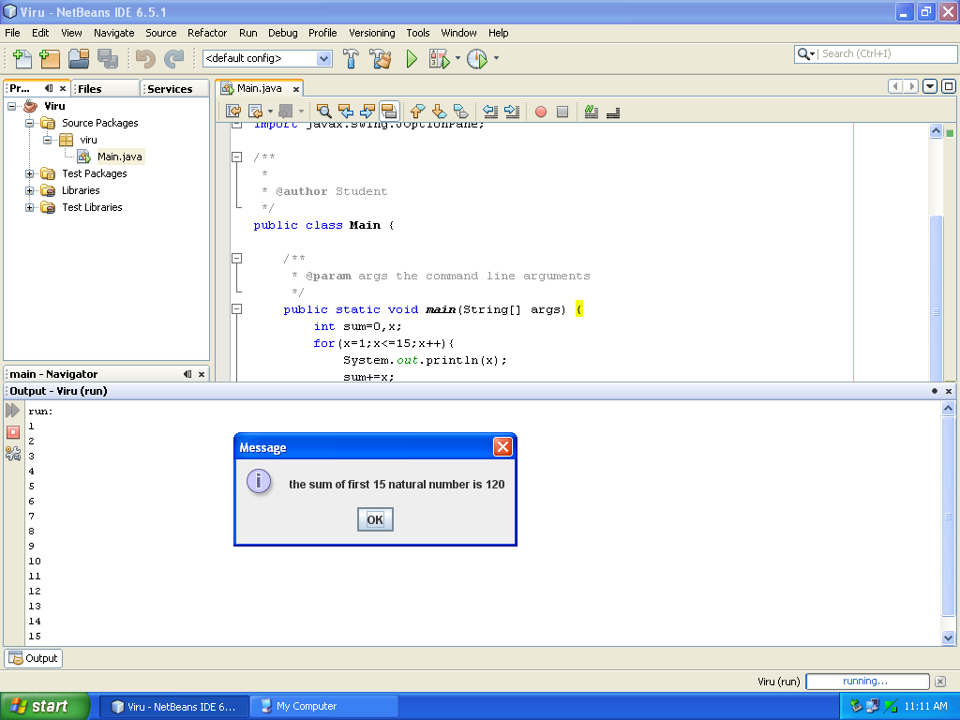

Q 1.Loop to print factorial of a given number?

import javax.swing.JOptionPane;

public static void main(String[] args) {
int num=3;
int factorial=1,a;
for(a=1;a<=num;++a){
factorial*=a;
}
JOptionPane.showMessageDialog(null,"the factorial of number "+num+" is "+factorial);
}

Q 2.Loop to print first 15 natural number and their sum?

import javax.swing.JOptionPane;

public static void main(String[] args) {
int sum=0,x;
for(x=1;x<=15;x++){
System.out.println(x);
sum+=x;
}
JOptionPane.showMessageDialog(null,"the sum of first 15 natural number is "+sum);
}

Result 3

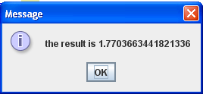

Result 4

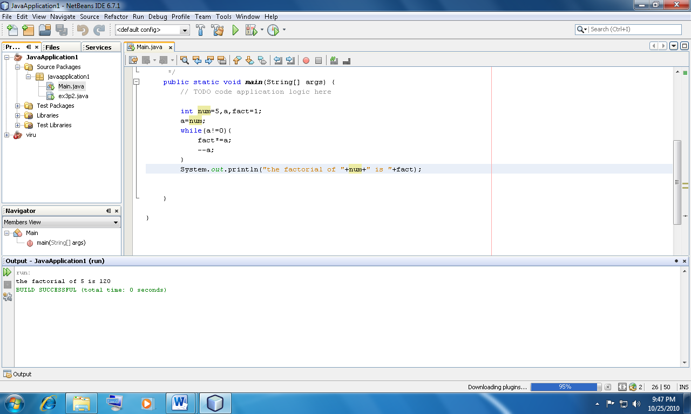

Q 3. Loop to print the sum of following series?

import javax.swing.JOptionPane;

public static void main(String[] args) {
double x,sum,term;
sum=0;
for(x=1;x<=25;x+=3){
term=1/x;
sum+=term;
}
JOptionPane.showMessageDialog(null,"the result is "+sum);
}

Q 4. Code to calculate the factorial of an integer using while loop?

public static void main(String[] args) {
int num=5,a,fact=1;
a=num;
while(a!=0){
fact*=a;
--a;
}
System.out.println("the factorial of "+a+" is "+fact);
}

Result 5

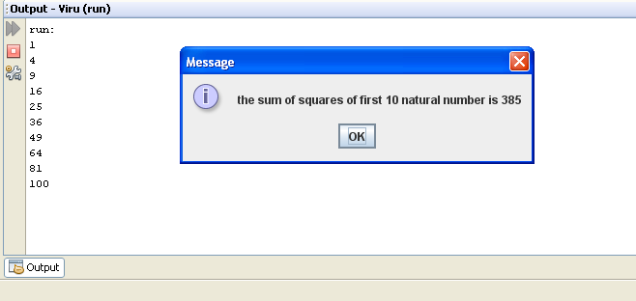

Result 6

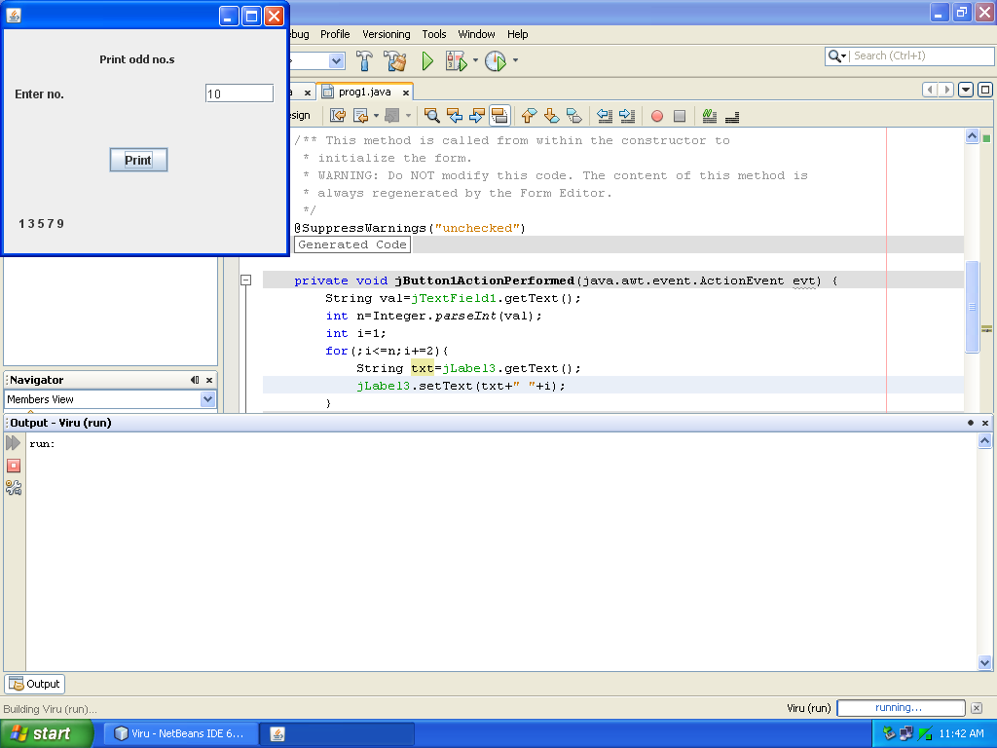

Q 5. Code to print series of squares of first 10 natural number and their sum?

import javax.swing.JOptionPane;

public static void main(String[] args) {
int sum=0,sq=0;
int n=1;
while(n<=10){
sq=n*n;
System.out.println(sq);
sum+=sq;
n++;
}
JOptionPane.showMessageDialog(null,"the sum of squares of first 10 natural number is "+sum);
}

Q 6. Design an GUI application to show n odd number less then input number?

private void printBtnmeri ActionPerformed(java.awt.event.ActionEvent evt) {
String val=inpTF.getText();
int n=Integer.parseInt(val);
int i=1;
for(;i<=n;i+=2){
String txt=resLB.getText();
resLB.setText(txt+" "+i);
}
}

Result 7

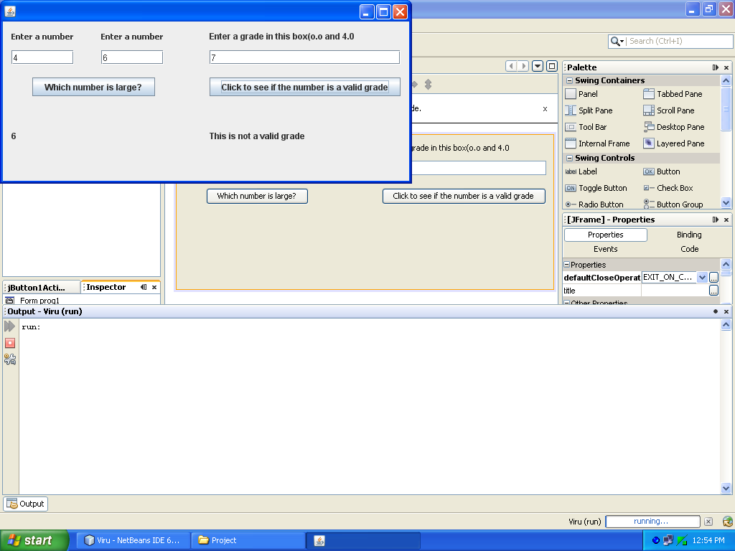

Result 8

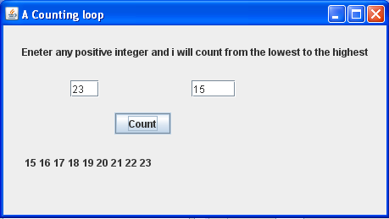

Q 7. Design a GUI application to check which number is greater of two and to check the validity of a grade?

private void checkActionPerformed(java.awt.event.ActionEvent evt) {
int num1=Integer.parseInt(num1TF.getText());
int num2=Integer.parseInt(num2TF.getText());
if(num1<num2)
outLB.setText(""+num2);
else
outLB.setText(""+num1);
}

private void gradeCalActionPerformed(java.awt.event.ActionEvent evt) {
int num1=Integer.parseInt(gradeTF.getText());
if(num1>=0&&num1<=4)
resLB.setText("This is a valid grade");
else
resLB.setText("This is not a valid grade");
}

Q 8. Design a GUI application to print number from lowest to greatest of two number?

private void countBtnActionPerformed(java.awt.event.ActionEvent evt) {
int num1=Integer.parseInt(num1TF.getText());
int num2=Integer.parseInt(num2TF.getText());
String loop="";
if(num1<num2){
for(;num1<=num2;num1++){
loop=loop+" "+num1;
}
}
else{
for(;num2<=num1;num2++){
loop=loop+" "+num2;
}
}
resLB.setText(loop);
}

Result 9(a)

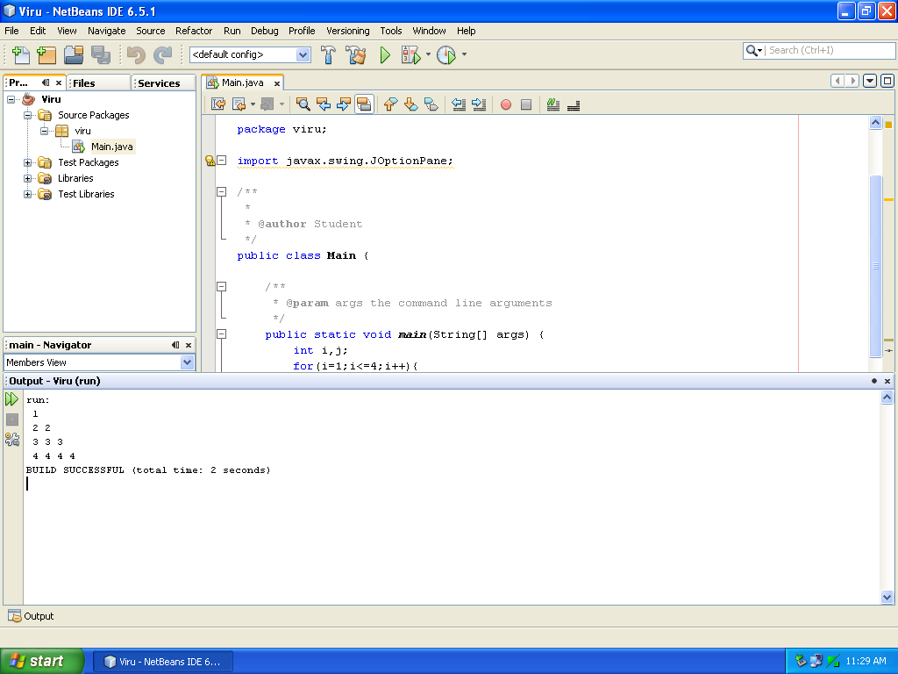

Result 9 (b)

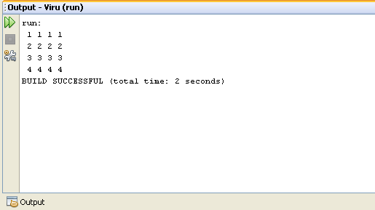

Q 9. Write the code to display the given pattern?
(a)
public static void main(String[] args) {
int i,j;
for(i=1;i<=4;i++){
for(j=1;j<=i;j++)
System.out.print(" "+i);
System.out.println();
}
}

9(b)

public static void main(String[] args) {
int i,j;
for(i=1;i<=4;i++){
for(j=1;j<=4;j++)
System.out.print(" "+i);
System.out.println();
}
}

Result 9(c)

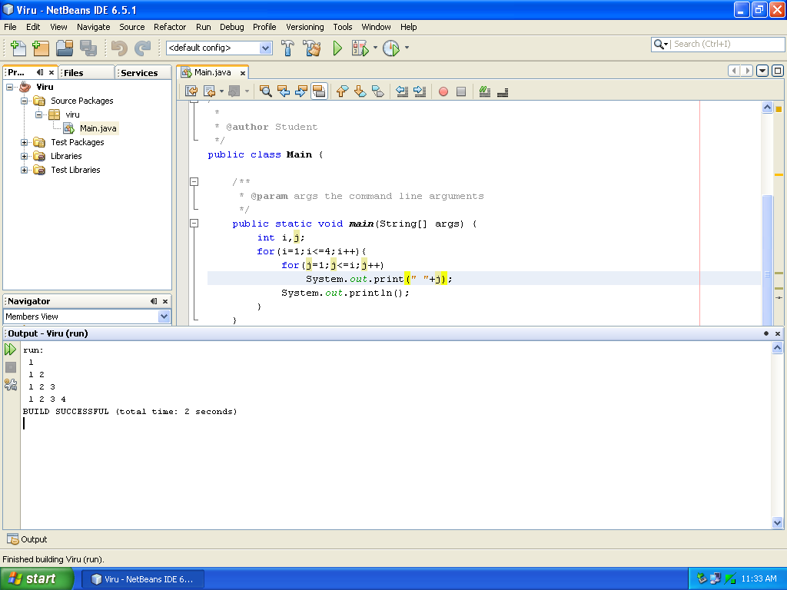

Result 9(d)

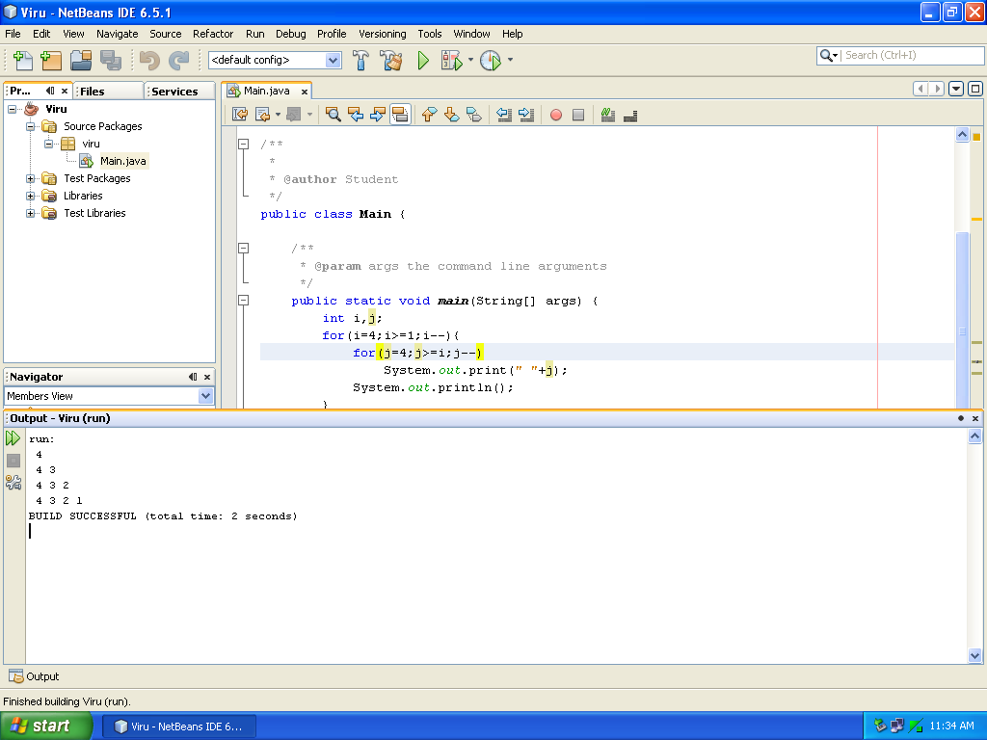

9(c)

public static void main(String[] args) {
int i,j;
for(i=1;i<=4;i++){
for(j=1;j<=i;j++)
System.out.print(" "+j);
System.out.println();
}
}

9(d)

public static void main(String[] args) {
int i,j;
for(i=4;i>=1;i--){
for(j=4;j>=i;j--)
System.out.print(" "+j);
System.out.println();
}
}

Result 9(e)

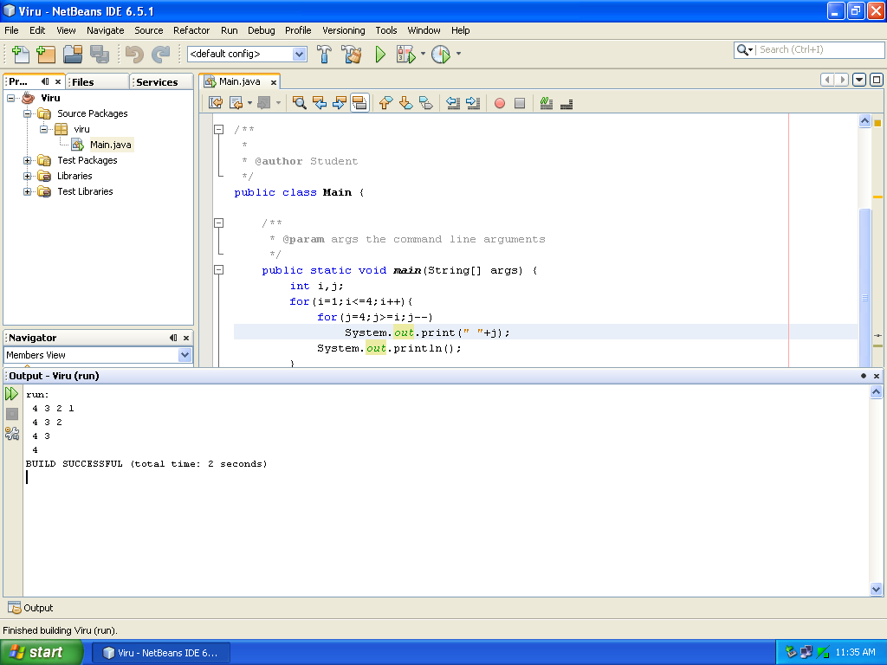

Result 10

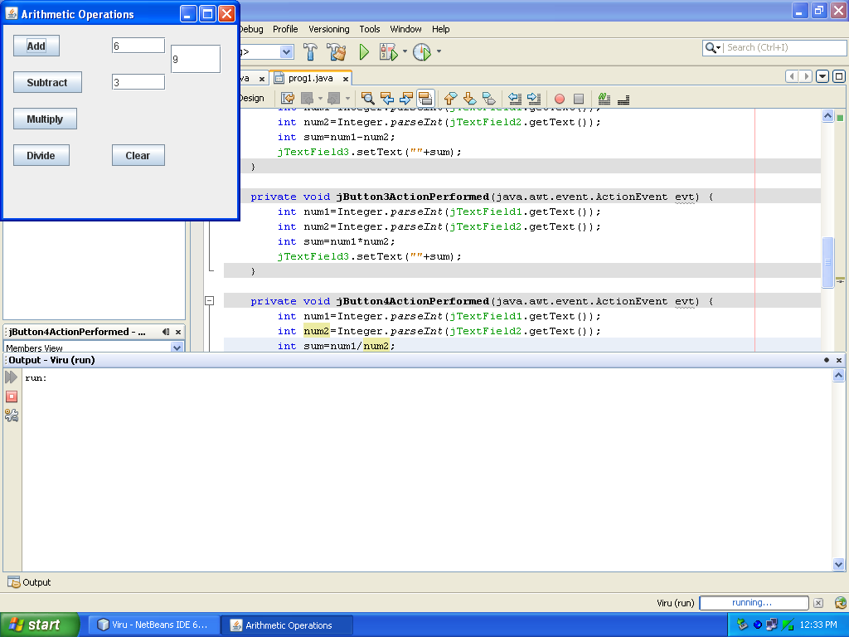

9(e)

public static void main(String[] args) {
int i,j;
for(i=1;i<=4;i++){
for(j=4;j>=i;j--)
System.out.print(" "+j);
System.out.println();
}
}

Q10. Design a GUI application that perform arithmetic operations?

private void addActionPerformed(java.awt.event.ActionEvent evt) {
int num1=Integer.parseInt(num1TF.getText());
int num2=Integer.parseInt(num2TF.getText());
int sum=num1+num2;
resTF.setText(""+sum);
}

private void sabtractActionPerformed(java.awt.event.ActionEvent evt) {
int num1=Integer.parseInt(num1TF.getText());
int num2=Integer.parseInt(num2TF.getText());
int dif=num1-num2;
resTF.setText(""+dif);
}

private void multiplyActionPerformed(java.awt.event.ActionEvent evt) {
int num1=Integer.parseInt(num1TF.getText());
int num2=Integer.parseInt(num2TF.getText());
int prd=num1*num2;
resTF.setText(""+prd);
}

private void divideActionPerformed(java.awt.event.ActionEvent evt) {
int num1=Integer.parseInt(num1TF.getText());
int num2=Integer.parseInt(num2TF.getText());
int div=num1/num2;
resTF.setText(""+div);
}

private void clearbtnActionPerformed(java.awt.event.ActionEvent evt) {
num1TF.setText("");
num2TF.setText("");
resTF.setText("");
Result 11

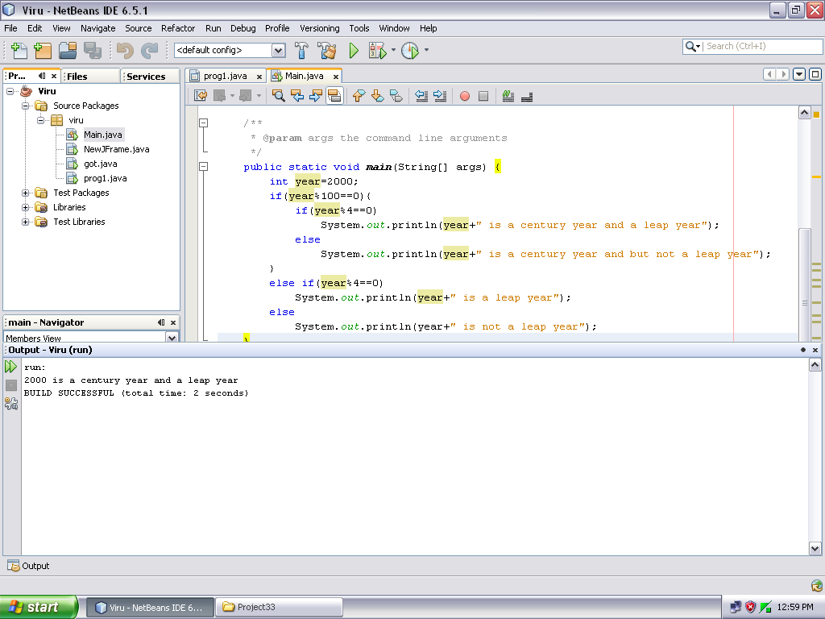

Result 12

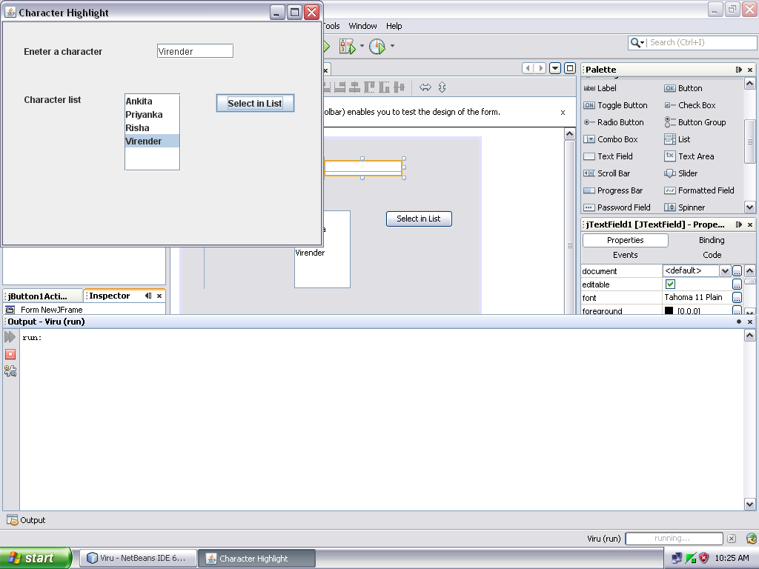

Q 11. Write code to check whether a year is leap year or not as well as a century?

public static void main(String[] args) {
int year=2000;
if(year%100==0){
if(year%4==0)
System.out.println(year+" is a century year and a leap year");
else
System.out.println(year+" is a century year and but not a leap year");
}
else if(year%4==0)
System.out.println(year+" is a leap year");
else
System.out.println(year+" is not a leap year");
}

Q 12. Design a GUI application in which whenever a character is typed in the text field the corresponding letter get highlighted in the list ?

private void selBtnActionPerformed(java.awt.event.ActionEvent evt) {
charList.setSelectedValue(srchTF.getText(),true);
}

Result 13

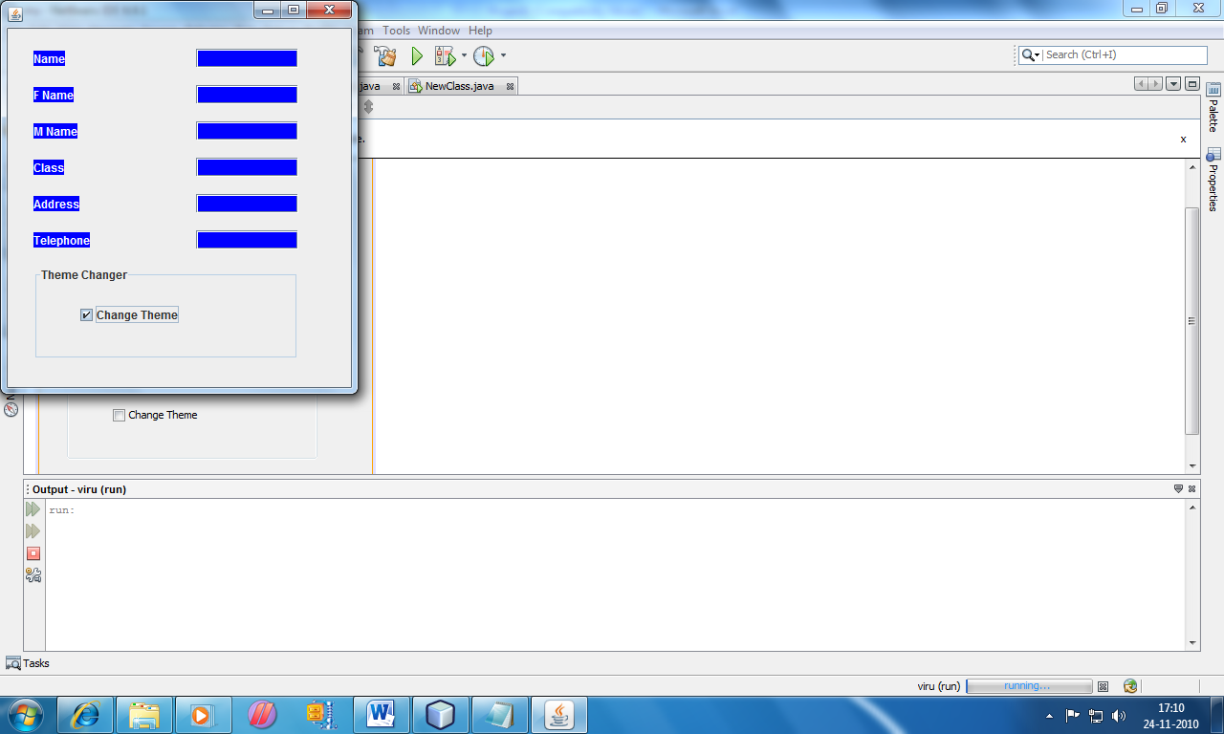

Result 14

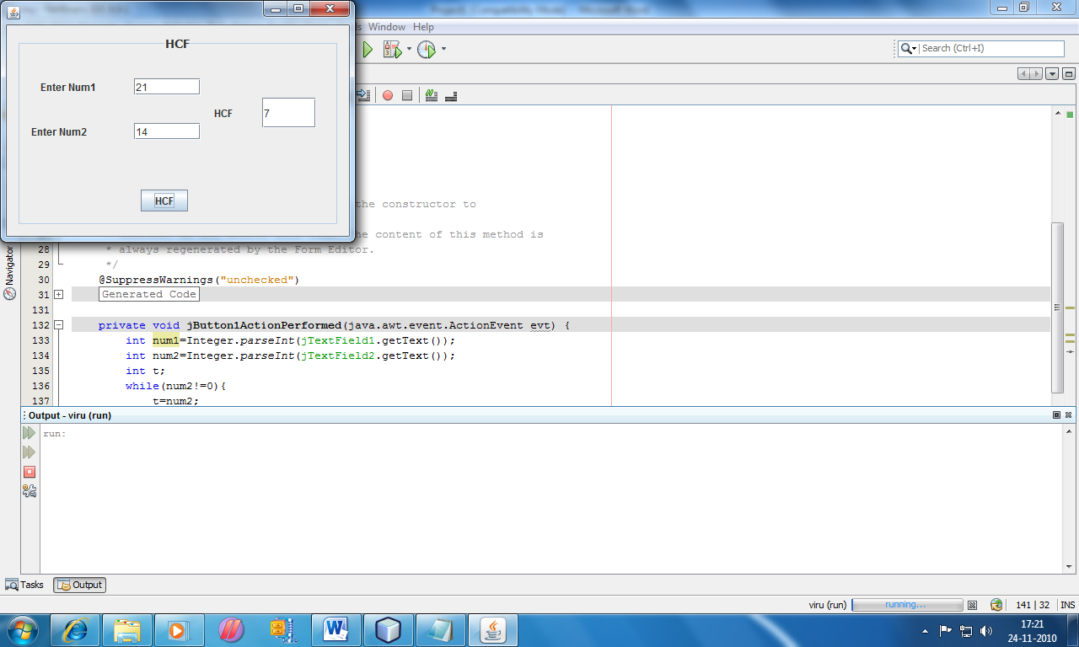
Q 13. Design a GUI application in which whenever check box is selected the colour of labels and text field become blue and the colour of yexy in label become white?

private void changeThemeActionPerformed(java.awt.event.ActionEvent evt) {
nameTF.setBackground(Color.BLUE);
FnameTF.setBackground(Color.BLUE);
MnameTF.setBackground(Color.BLUE);
classTF.setBackground(Color.BLUE);
addTF.setBackground(Color.BLUE);
phTF.setBackground(Color.BLUE);
nameLB.setBackground(Color.BLUE);
FnameLB.setBackground(Color.BLUE);
MnameLB.setBackground(Color.BLUE);
classLB.setBackground(Color.BLUE);
addLB.setBackground(Color.BLUE);
phLB.setBackground(Color.BLUE);
nameLB.setForeground(Color.WHITE);
FnameLB.setForeground(Color.WHITE);
MnameLB.setForeground(Color.WHITE);
classLb.setForeground(Color.WHITE);
addLB.setForeground(Color.WHITE);
phLB.setForeground(Color.WHITE);
}

Q 14. Design a GUI application to calculate HCF of 2 natural number?

private void HCFcalActionPerformed(java.awt.event.ActionEvent evt) {
int num1=Integer.parseInt(num1TF.getText());
int num2=Integer.parseInt(num2TF.getText());
int t;
while(num2!=0){
t=num2;
num2=num1%t;
num1=t;
}
resTF.setText(""+num1);
}

Result 15

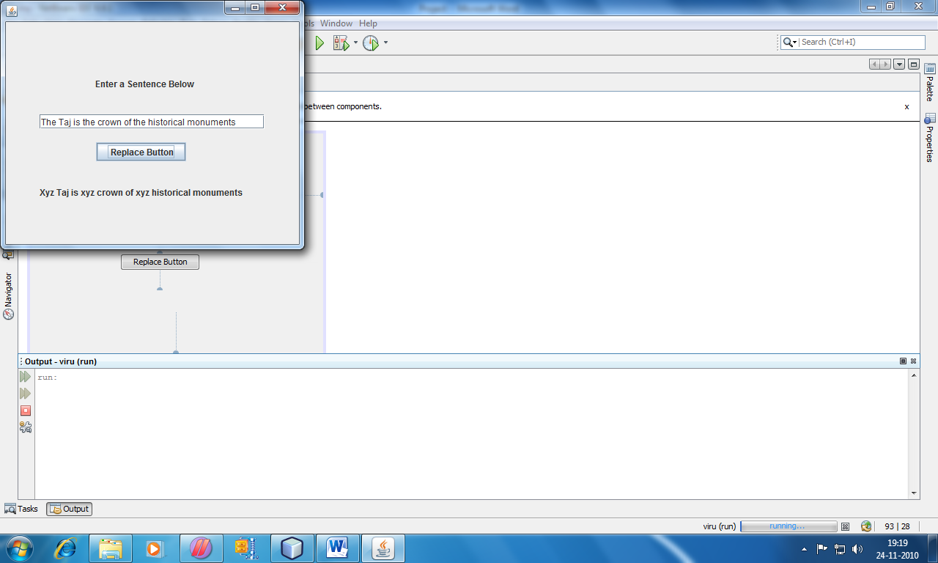

Result 16

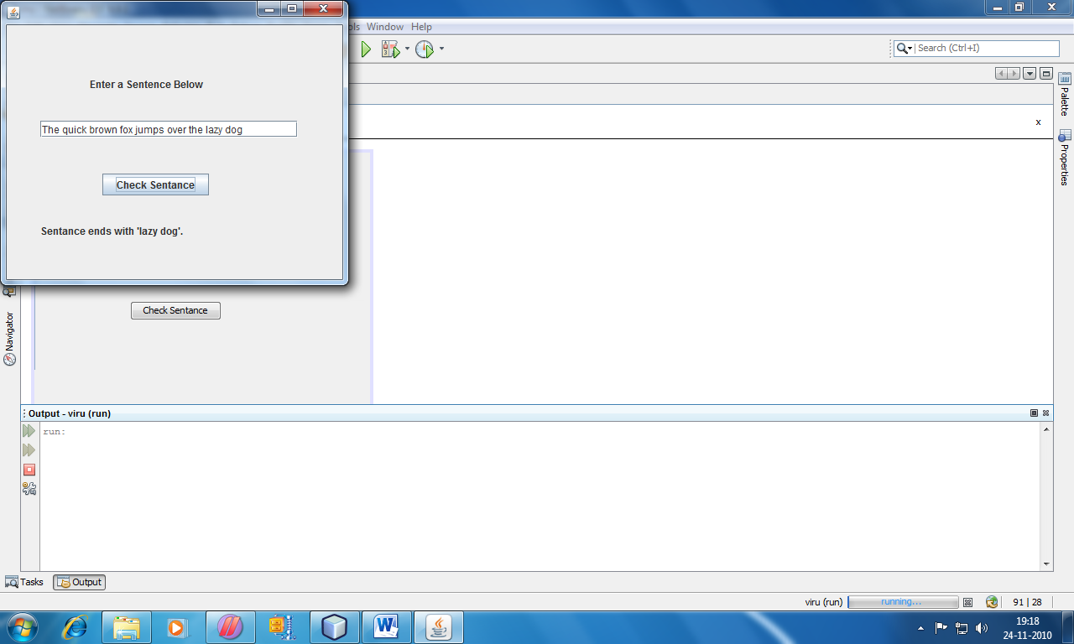

Q 15. Write a program to read a sentence and replace every “The” with “Xyz” and “the” with “xyz”?

private void replaceBtnActionPerformed(java.awt.event.ActionEvent evt) {
String str;
str=senTF.getText();
str=str.replace("The","Xyz");
str=str.replace("the","xyz");
outLB.setText(str);
}

Q 16. Write a program to read a sentence and check whether it ends with “lazy doy”?

private void checkBtnActionPerformed(java.awt.event.ActionEvent evt) {
String str=senTF.getText();
StringBuffer s=new StringBuffer("");
if(str.endsWith("lazy dog")){
s.append("Sentance ends with 'lazy dog'.");
}
else{
s.append("sentence does not ends with 'lazy dog'.");
}
String out=new String(s);
outLB.setText(out);
}

Result 17

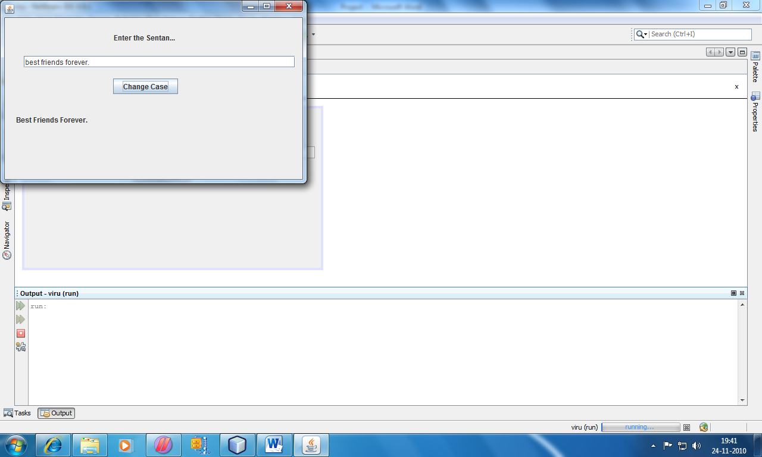

Result 18

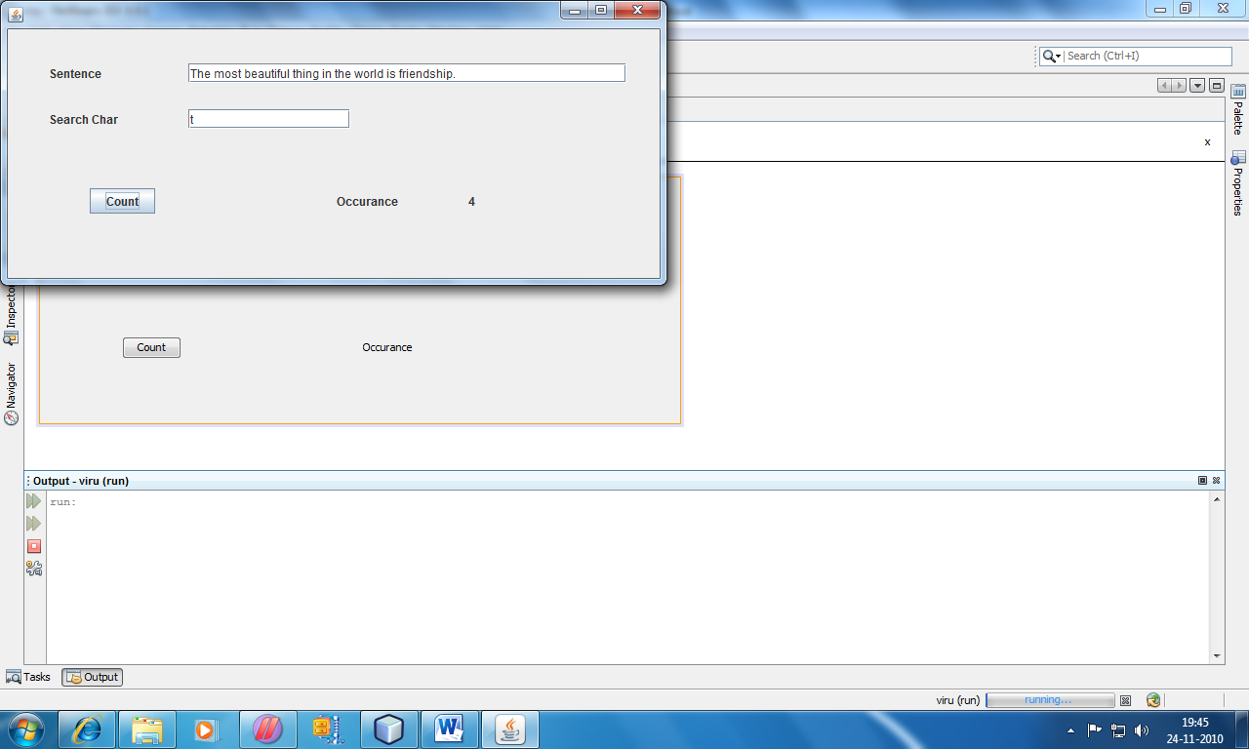

Q 17.Design a GUI application to change every first letter of a word in a sentence to uppercase?

private void changeBtnActionPerformed(java.awt.event.ActionEvent evt) {
String str=senTF.getText();
int len=str.length();
char ch=Character.toUpperCase(str.charAt(0));
str=ch+str.substring(1);
for(int i=2;i<len-1;i++){
if(str.charAt(i)==' '){
ch=Character.toUpperCase(str.charAt(i+1));
str=str.substring(0,i+1)+ch+str.substring(i+2);
}
}
outLB.setText(str);
}

Q 18. Design a GUI application to count the occurrence of particular character in a string?

private void countBtnActionPerformed(java.awt.event.ActionEvent evt) {
String str=senTF.getText();
char ch=chTF.getText().charAt(0);
int count=0;
for(int i=0;i<str.length();i++){
if(str.charAt(i)==ch)
count++;
}
occurLB.setText(""+count);
}

Result 19.

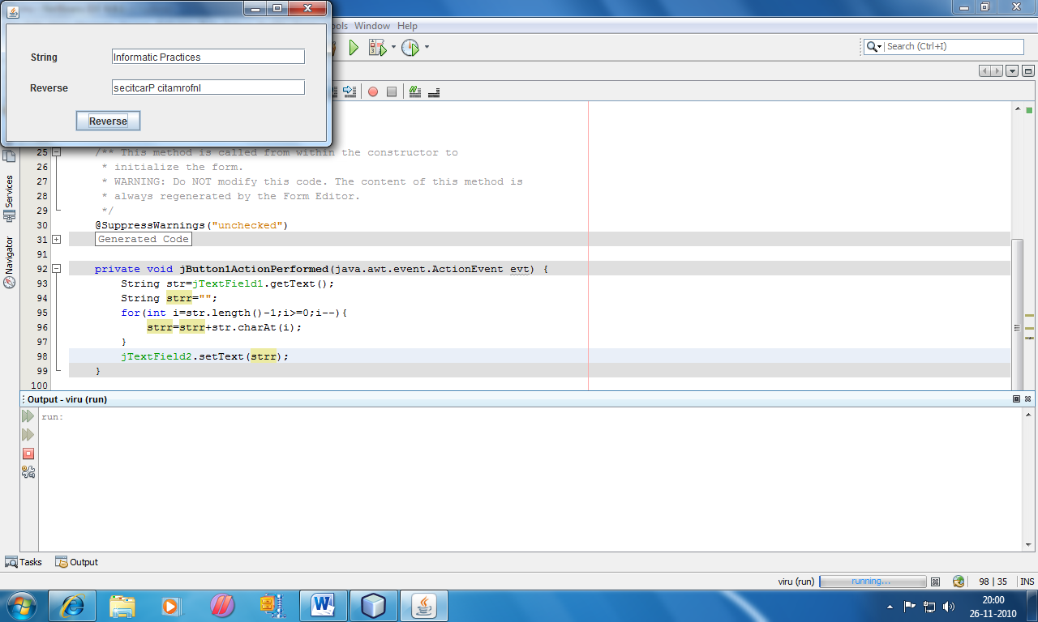

Result 20.

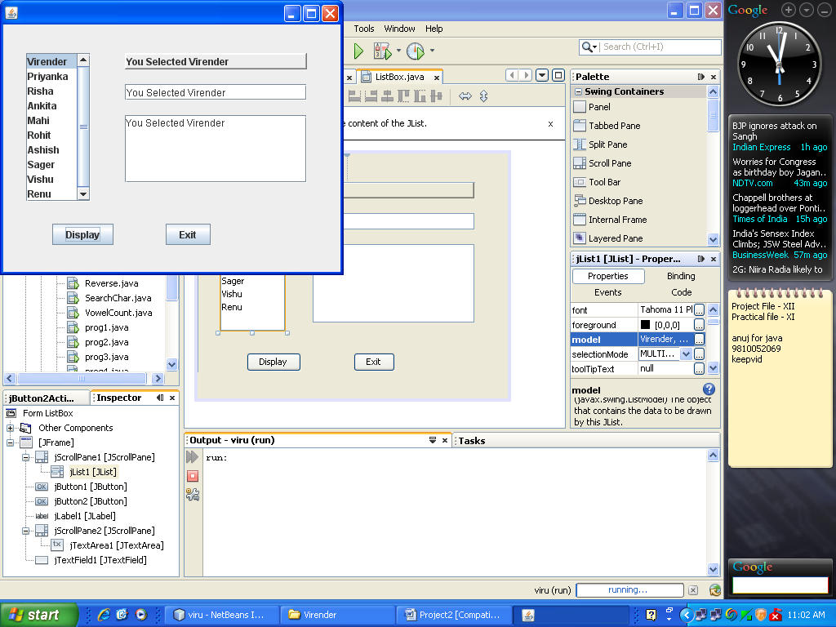

Q 19. Design a GUI application to reverse the input string in text field and display it in another text field?

private void RevBtnActionPerformed(java.awt.event.ActionEvent evt) {
String str=stringTF.getText();
String strr="";
for(int i=str.length()-1;i>=0;i--){
strr=strr+str.charAt(i);
}
revTF.setText(strr);
}

Q 20. Design a GUI application to display the selected value of List in Text Field, Label and Text Area?

private void ExitBtnActionPerformed(java.awt.event.ActionEvent evt) {
System.exit(0);
}

private void DisplayBtnActionPerformed(java.awt.event.ActionEvent evt) {
String pName=(String)jList1.getSelectedValue();
Label.setText("You Selected "+pName);
TextField.setText("You Selected "+pName);
TextArea.append("You Selected "+pName);
}

Result 21.

